Autism Skill Tutor

Content Theory by Gianna Rasmussen

# Introduction

Two of the greatest challenges people with high-functioning autism can face are (1) low autistic-confidence and (2) sensory processing/sensory sensitivity problems. (1) and (2) are highly individualized and nuanced problems that very few models of autism treatment acknowledge or handle. This content theory proposes a program that will help high-functioning autistic children develop their socialization skills in a way that adheres to their comfort levels, techniques to help process emotions and over-stimulation, and will give them confidence in their autistic traits.

# Terms

**Applied Behavior Analysis (ABA)**

A type of therapy focusing on improving behaviors and skills, currently one of the most common forms of autism therapy (Palestra, De Carolis and Esposito 2017).

**Asperger’s Syndrome**

A form of functional ASD, typical traits include impaired social skills, obsessive interest(s), impaired motor development, and a strict adherence to routine.

**Autism Spectrum Disorder (ASD) / Autism Disorder**

A developmental disorder that has a large range of intensity that can impair communication, social development, motor skills, and mental development.

**Autistic-Confidence**

The level of comfort and acceptance of the individual with their identity as a person with autism.

**Functioning Autism / High-Functioning Autism (HFA)**

Autism that does not exhibit an intellectual disability, allowing for the person to function and live independently.

**Hyperfocus**

The process of being so intensely focused that they are unable to process anything outside of the area of focus. This can include both physical and emotional feelings, and the world around them.

**Masking / Camouflaging / Adaptive Morphing**

The practice of a person with autism suppressing behaviors identified as “autistic” and performing behaviors to attempt to present as neurotypical.

**Neurodivergant**

Someone who has a mental disorder or mental illness.

**Neurotypical**

Someone who does not have a mental disorder or a mental illness, the ‘typical’ brain.

**Non-Functioning Autism / Low-Functioning Autism (LFA)**

Unable to live independently, autism has had a highly debilitating effect on the person and needs assistance.

**Pervasive Developmental Disorder - Not Otherwise Specified (PDD-NOS)**

Mild symptoms/traits of autism or may not have all signs of autism and includes the subtypes of autism that do not fall under Asperger’s Syndrome or Autistic Disorder.

**Sensory Sensitivity / Sensory Processing Sensitivity**

Some sensory stimuli have heightened processing. This can affect any of the five senses and can be overwhelming and painful, leading to sensory overload.

**Special Interest/Fixation**

The area of interest of a person with autism in which they are fixated on. It is usually a hobby in which the person has a very deep focus on, to the point that it may appear obsessive.

**Treatment**

Treatment, in the context of this content theory, is the development of skills or practices that make living with a disability easier. Is not an indicator that this content theory proposes a cure or way to get rid of the symptoms/traits of ASD.

# Problems with Current Models

As a person with autism, I have found that a lot of proposed and existing treatments for autism care more about making me seem “normal” than my personal happiness.

A major red flag for me is any treatment involving ABA, which is used in a majority of autism treatments including robots being developed to treat autism currently (Palestra, De Carolis and Esposito 2017). Not only does ABA increase the likelihood of experiencing symptoms of or developing PTSD, but it was also found that it tends to ignore the boundaries and comfort levels of the people receiving the treatment (Kupferstein 2018). This kind of treatment can also lead to the development of masking, which can worsen mental health and make it harder to cope with having autism (Cook, et al. 2021).

NAO, an AI robot, is the perfect example of something that is meant to help children with autism, but just teaches masking and ignores a child’s comfort levels. NAO teaches eye contact, joint attention, body imitation, facial imitation, and facial expression imitation (Palestra, De Carolis and Esposito 2017). Of those, only joint attention has potential to not teach something damaging.

Any form of teaching imitation is teaching masking. People in the autistic community already learn to mask subconsciously, having professionals reinforce the idea that they should mask is dangerous and should not happen (Lawson 2020).

While eye contact seems like a great skill to teach to people with autism in theory, it is probably one of the least important skills I have needed to develop to cope with autism in my life. And the most helpful skill I have learned for doing so is not one that any model I have seen teaches: how to appear as though you are making eye-contact without actually doing so. This skill allows me to be somewhat comfortable in a conversation while still appeasing the social demand of eye-contact.

There are some treatments better than NAO, however. One in-home social robot helped children with autism develop skills through games and also improved parent-child communication (Scassellati, et al. 2018). This robot was child-friendly, and did not do any of the behavior corrections found in treatments that follow the ABA model. The biggest problems with this form of treatment is the cost, which is assumed to be high with all the materials that would need to be purchased, and the dependency on parent-child interaction. Not all parents have time to do these activities for thirty minutes a day.

Of all the models of treatment I read about, very few had children with HFA in mind, focusing instead on those with LFA, and none gave any support in developing autistic-confidence, leaving a critical gap in resources and treatment for children with HFA.

# Scope

This paper proposes a downloadable computer program and does not consider other forms of implementation. As such, the intended users for the proposed computer program are American children between the ages of 7 and 14, with some consideration for those above the age of 14, that have HFA. Though the techniques to be proposed are applicable to those without autism, this paper will not consider uses outside of application towards treating autism.

# Contents

## Character Model and Design Choices

### Main Model

The main model (left), which will be used in all the chat features and on the home page, has a simple body and a customizable face (indicated by the darkened circle labeled NF).

On the home page there will be an option to change and edit the main model (below).

Users will then be given the option to edit the current model, make a new model, or select from existing models.



#### Existing Models



The existing models screen allows for the user to see all character models that they can use as their main one. The user can scroll through the existing characters by clicking the arrows at the bottom of the page. The user will have access to all the cartoon-like characters used for the games and in the guides. Pre-existing characters will have their names displayed above them, while user-made characters will have their names appear below.

Each game character will have a consistent personality and have highly prevalent autistic traits, which are displayed in the games, guides, and through their emotional reactions.

Their display of autistic traits will help bring comfort and a sense of normality to users who may struggle with or feel-self conscious about certain traits. This will help develop a sense of belonging and help combat the absent-self which makes people with HFA resistant to socializing (Lombardo, et al. 2009).

##### Nene

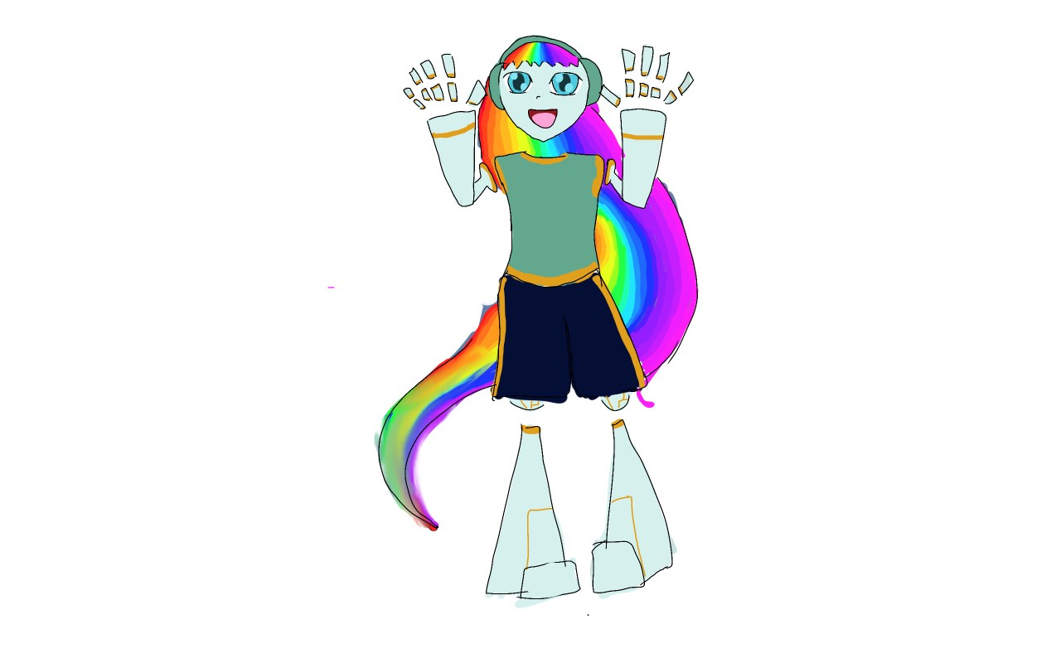

Nene is highly emotive, and stims with her hair when she feels intense emotions. Many people with autism stim as a soothing self-regulatory mechanism (Kap, et al. 2019). She expresses her emotions physically and verbally.

##### Pat

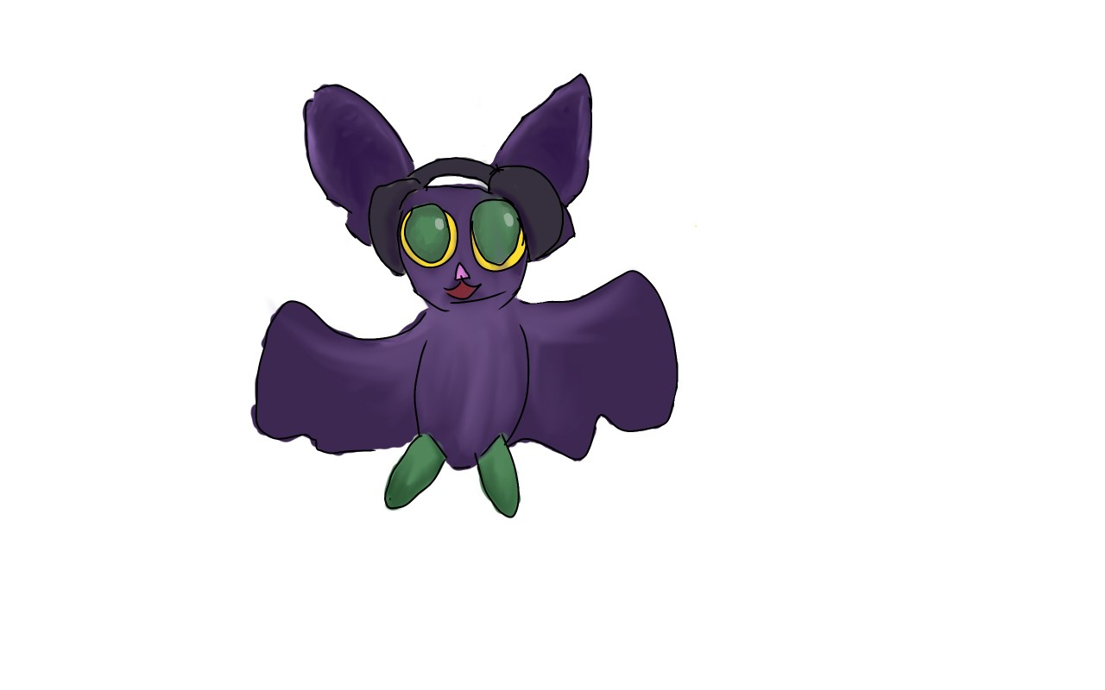

Pat has sensory processing problems and has a motor impairment that makes it hard for her to fly. Motor impairments are most prevalent in children with ASD, and though they often go away or improve over time, it is important to represent this autistic trait (Ming, et al. 2007). She expresses emotions facially and verbally.

##### Bob

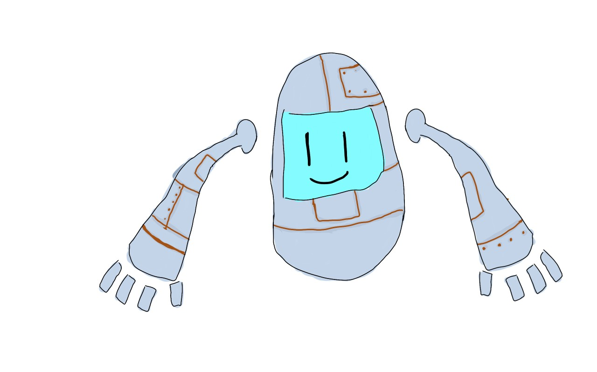

Bob is bad with words, but has a highly emotive face. Many with autism struggle to communicate and talk, just like Bob. He expresses his emotions with his face.

##### Devan & Devin

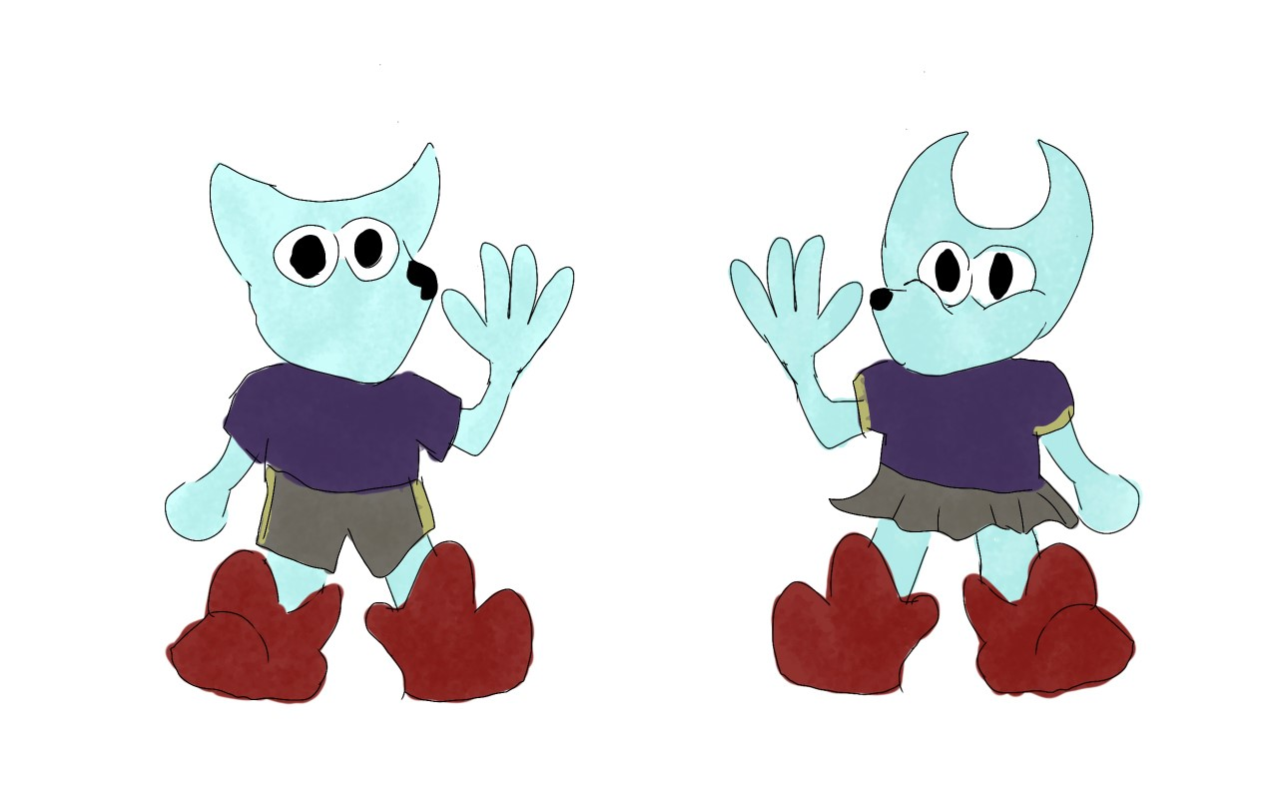

Devan (left) & Devin (right) are mute and express their emotions through their eyes and physically. Devin expresses more through their eyes, while Devan uses more body language. Both have a special interest in basketball.

##### Winn

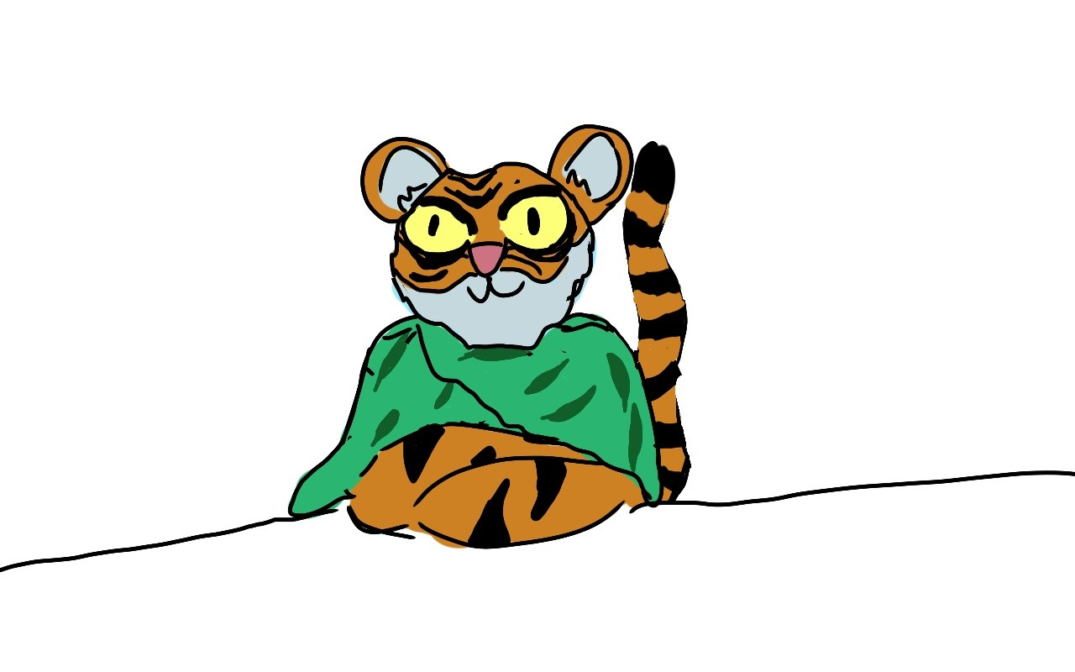

Winn does not feel comfortable without his blanket wrapped around him. He does not feel comfortable making eye contact and will often look anywhere except the eyes. He expresses his emotions verbally.

These models will each have thirteen displays of emotion, the core twelve that each model the user can make has, plus one extra that will occasionally replace the neutral expression.

In games where more than six characters are needed (such as Match the Feeling and Who AmI?) modified versions of the characters will be included. The characters will have different color schemes and/or minor alterations so they are distinct from the base character.

Along with the game characters, the user can make up to twenty different characters.

### Making a Model

To make a new model the user will be prompted to upload photos of a face with different expressions.

| Expression | Reference Label | Emojis |
| --- | --- | --- |
| Happy | HF | 😀 😁 🌞❤️😊🤠 |
| Surprised | SRF | 🤯😮 😲 ⁉️ ‼️👀 |
| Sad | SDF | 😢 🙁☹️😭 😟 😿 |
| Confused | CF | 🤨❓😵‍💫😶 🤔🧐 |
| Thinking | TF |
| Neutral | NF | 👾🤖✨👁️‍🗨️🎶🎵✔️ |
| Laughing | LF | 🙃 😝👅🤭 😸 😜 |
| Fear | FF | 😱 😨 😬 😖 😣 😮 |
| Disgust | DF | 🤢🤮 😵 🥵☢️ |
| Embarrassed | EF | 😓 😳 |
| Angry | AF | ❌😒 😡 😤😠 👿 |
| Relief | RF | 😮‍💨😅😌 |
| Emotional Reference Table | | |

The program will then stick the faces onto the model, which the user can name and save to the group of existing models, which can be saved to a list of structures.

Office Depot’s Elf Yourself and HAL Laboratories' Face Raiders use a similar concept of uploading photos of faces and putting them onto pre-made characters, only this would have a few extra steps as different emotions have to be given.

The program will be able to call upon the different saved emotions by accessing the data saved in the struct of the active model.

The user can change expressions for the different emotions at any time by editing the current model, which would be editing the values of the specific structure that the model is saved under.

The benefits of this customizable model are that users will gain more enjoyment out of interacting with the AI, and therefore be more likely to want to use the program. It also caters to popular culture, as the user can take the face of celebrities or their favorite characters and stick them onto the model.

## Home Screen



Concept Structure of Home Screen

Upon opening the program, the user will be taken to a home screen with the main model waving to them. This is where they will be able to select which of the three areas they would like to go into.

1. Social Development
2. Games
3. Guides

The three areas are based on what I perceive to be the three most helpful tools that can be provided to someone with autism.

Social development focuses on improving social skills in a more natural way. The user can ask the AI questions about social expectations that they do not understand or that they want to develop, or talk out a problem. The AI will not judge the user, and provides a safe space to vent.

The games section has seven different games to help develop emotional awareness and techniques to help with overstimulation and overwhelming feelings.

The guides section provides information on many different aspects of autism, presented in an easy-to-read way with pictures. Children can understand themselves and their autistic traits better, and it is explained by characters that deal with the same things as them.

By clicking one of the buttons, the user will enter the section and be able to view and choose one of the options within the section.

## Social Development

This section of the program will focus on developing the user’s social skills, with two different ways the user can interact with the AI. A pointer indicates which section the user would like to go into, with an accompanying image to match with the option.

### Talk to AI

The chat function is where the user can freely talk to the AI without restriction.





The user will have two options: voice chat and text chat.

#### 

In voice chat the model will have two modes: Emot Off (left) and Emot On (right) and will be able to process audio to identify whether the user is speaking. To do so the program will be trained to be able to distinguish voices from background noise.

When Emot is off, the figure will have a neutral expression and do small indicators such as nodding to display to the user that it is listening. The model will stop nodding when the user stops speaking.

When Emot is on, whenever the user stops speaking the program will choose a random expression and emoji from the Emotions Reference Table.



The text chat will implement an AI that tries to mirror the emotions of the user by searching for specific patterns and words within the user’s text. The AI will react either facially and with emojis (right) or only facially (left).

#### Examples:

1. The user sends the message: Wow, I had such a bad day!

The AI would scan the text and pull out the words “Wow” and “bad” and the exclamation point as well as the places in the text that the words occur.

Next, the AI will look at the distance between the recorded words. All recorded words with a position that is within three of each other will be considered related and linked.

“Bad” and “!” are linked. Linked words hold more weight than non-linked words.

The AI will check to see if any words recorded are the first word. In this case that is true. Because “Wow” is not linked and is the first word, it takes on its base emotion type of happy.

Because the first word is happy, the AI will check for recorded punctuation.

In this case there is recorded punctuation, “!”. Happy first word + ! = surprised.

The AI will check to see if any recorded words come after the punctuation. Because none exist, the AI will ignore the rest of the recorded words.

Happy First Word + “!” = surprised response.

That pattern of speech would lead to the AI choosing a surprised response.

1. The user sends the message: I ate something very gross today, it was not bad…

The AI records the words “gross”, “bad”, and the “...” at the end.

Next, the AI will look at the distance between the recorded words. All recorded words with a position that is within three of each other will be considered related and linked.

“bad” and “...” are linked.

Since “gross” is not the first word, the AI will move on to check if any word that has an unrecorded word before it by looking at the positions of the words. “Gross” and “bad” both have unknown words before them.

The AI will look at the word before gross, “very”. “Very” is considered an enhancer word, so the AI checks to see if there is an unknown word before that one. In this case, it does, and the AI checks the word before “very” which is “something”. The AI does not know that word and moves onto the next case.

The word before bad is “not”, which the AI will recognize and note that.

Finally, the emotions of the recorded values are processed.

“Gross” is unlinked and unmarked, indicating that it has its primary emotional value of disgust.

“Bad” unmarked would produce a sad response.

“....” unlinked would produce a sad response.

“Bad” linked with “...” would produce a sad response.

“Bad” marked would produce a happy response.

“Bad” linked with “....” and marked would produce a confused response.

Happy + Sad = Confused response.

Because the linked words hold more weight, the AI would return a confused response.

1. The user sends the message: Bleh I ate something very gross today, but it was not bad…

The AI records the words “Bleh, “gross”, “bad”, and the “...” at the end.

“bad” and “...” are linked.

Because “Bleh” is the first word, and unlinked, the AI will take its emotion type of disgust and check it against the punctuation.

“....” does not go with disgust words, and therefore the AI will continue on.

From here it goes the same as it did in example 2 until the end.

Because both “bleh” and “gross” are disgust words, they hold the same weight as “bad” linked with “....”.

Disgust + confused = surprised response.

The AI would return a surprised response.

1. The user sends the message: I am who I am.

The AI records no words. Because no words are recorded, it returns a neutral response.

### Social Questions

Social Questions will help the user understand and learn how to understand their interactions with others. The AI will have a list of subjects that people with Autism may struggle with and an option to talk out a problem.

.



The Questions section is where the user can get their questions about socializing answered by the AI.



#### Topics

* Making Eye Contact
  + Why do I have to do it?
  + Tips and tricks to making eye contact
  + I am uncomfortable with making eye contact
* Dominating a Conversation
  + I am not interested in what others have to say
  + I just want to talk about one thing
  + I want to but I always end up taking over.
* Hurting Someone’s Feelings
  + I do not know why I hurt someone’s feelings
  + How do I apologize?
  + Should I apologize?
  + How do I know if I hurt someone’s feelings?
* My Feelings are Hurt
  + How do I express that my feelings are hurt?
  + What do I do when someone hurts my feelings?
  + Should my feelings be hurt?
* Expressing My Needs
  + How do I explain that I cannot do something?
  + Why does no one understand when I try to express my needs?
  + How to non-verbally express my needs
  + How to verbally express my needs when I don’t know how to
  + How to tell if something is a need that should be expressed
* I am Frustrated
  + Why do teachers treat me differently?
  + Why can’t I just be normal?
  + People are making fun of me.

The existing topics are based upon the things people with autism may struggle with and what I believe would be helpful based on my own experiences.

Making eye contact differs from other methods of teaching autistic people to make eye-contact in that it focuses on assuring the user that they do not need to if they are uncomfortable, and teaches users how to appear as though they are making eye contact when they are not.

Dominating a Conversation focuses on suggesting ways in which the User can be more comfortable with how they communicate with others and things they can try to be less dominant in conversations.

Hurting Someone’s Feelings is a complex subject. It is easy for someone with autism to be unaware that they have done so, or not know how to respond when they do. This topic will help users understand how to go about dealing with hurting someone’s feelings in any situation.

My Feelings are Hurt aims to do the same thing as Hurting Someone’s Feelings, only with more introspection and reassurance.

Expressing My Needs gives some tips and tricks into how to communicate your needs to others, as well as an understanding of what needs are.

I am Frustrated exists because having high-functioning autism can be very frustrating and not many people not on the spectrum understand. This feature explains why and gives validation to the User’s frustration.



The user will be able to scroll through a list of questions related to the topic and click on the relevant question or statement.

The responses of the program are already written and are loaded when the user clicks the question or topic.

#### Talk It Out

The user is prompted to explain the problem to the AI, who will ask a series of questions in order to understand the problem or help the User gain new insight into the problem.

Questions the AI could ask:

* What is the problem?
* What happened?
* How does the problem make you feel?
* What do you think the perspective of the other person is?
* And how does that make you feel?



This feature will function similarly to the chatbot therapist ELIZA only with less sass and a bit more limited. Like ELIZA, it will implement pattern matching to respond somewhat relevantly.

When no response is relevant, it will tell the user to “go on”.

## Games

The Games section has games that help develop socialization skills such as being able to read and react to the emotions of others.





### Match The Feeling

The goal of this game is to be able to identify different emotions through images and/or text. It is a pretty simple matching game that gets more complex as you play.



Difficult 1: The User is given four different sentences and has to identify which sentence indicates which emotion.

Difficulty 2: The User is given an emotion and a choice of four different expressions in which the user has to match the emotion with the correct expression.

Difficulty 3: The User is given an emotion and a choice of four different people and must match the emotion based on body language without being able to see the face.

Difficulty 4: The User is given a list of characters and how they express different emotions. The User has to find which character is experiencing a specific emotion. The core six, as outlined in Existing Models, will have an unchanging way they express emotions. The rest will be assigned an expression sheet at random.

Each level will have a randomized emotion for the user to match with the character. The AI will first select four random characters from a list specifically made for the level. If any of the emotions are the same, the AI will re-generate characters until no emotions are the same.

From those emotions, the AI will randomize which one the user will have to match.

After getting five correct in a row, the next difficulty level will unlock.

This game teaches children how to recognize emotions in others regardless of how it is expressed, while giving assurance that it is okay to express things in non-traditional ways.

### What To Say

The User decides what emotion state they want to achieve within a conversation. This will help teach users about making conversation and getting an intended response out of someone.

At the start of the game, users will choose what emotion they want to elicit during the course of a conversation (picked from the list of emotions) and what character they want to talk to (picked from the list of existing models). There is an option to randomize both.



The starting mood of the character will be randomized from the list of emotions (excluding the objective emotional state).

The starting mood of the character will determine the possible conversation routes available at the start.

Game characters will have special dialogue options. Nene will be able to have a conversation thread about music. Pat has a conversation about sensory processing and getting new noise-canceling headphones. Bob can ask for advice on talking. Devan will sign about playing basketball with Devin. Devin will sign about trying out for a basketball team. Winn will need help finding his blanket.

The player can end the conversation at any time, or can play out the conversation until the character being spoken to ends it. The user wins if when the conversation ends, the character is at the emotional goal.

For most conversation routes, the exchange of dialogue will only last five to ten rounds of back and forth. Only the special dialogue options can last longer as those tend to tell a story.

For each starting emotional state of a user created character, there are 12 potential starting dialogue options. For game characters, there are 13. Three of which will be chosen randomly by the program as options.

These 11 starting points per emotional starting state are not unique across all starting moods, many are shared to decrease the size of the dialogue tree.

Below is a visual of how the dialogue tree could work with just the first two sets of dialogue options.



On the second dialogue exchange phase, the player can backtrack on both saying “I love you” and saying “Your Shoes Look Stupid” by selecting “Just joking”.

Just joking will always cause the character to feel relief regardless of what came before it and allow for the generation of three new conversation starters.

To calculate the emotional state of the character, the AI will look at the pattern of emotion the user caused the character model to feel.

All starter dialogue has a base emotion that is independent of all past emotions.

When the conversation ends, one last emotion will be generated.

Example Game Play:



The user chooses the dialgoue “Your shoes look stupid”.



The character will have a sad face, and the new response options will be given. The user chooses to “Just joking”.



New starter dialogue is generated at “just joking”. The user decides to end the conversation.



Because the user ended the conversation after making the model character sad and then relieved, the character model ended up confused.

In this game, the user is learning about eliciting a reaction and how words affect others.

### Who Am I?

This game is pretty similar to “Guess Who” and helps develop the user’s listening skills.





The image above is a condensed version of what the game would look like. In implementation, there would be a larger variety of characters to make the game somewhat more challenging than having only the nine characters displayed.

When the user hovers over a character’s picture, the name will appear.

The user and AI will each be given a randomly generated character that the other is trying to guess.

Each turn the players can either guess the character, or select a yes or no question.

The user will have a list of yes or no questions that they can ask the AI to discover its character. The AI does not lie when answering.

The user has the option to lie, and with every lie the odds of the AI noticing at the end of the game go up.

One lie has a 15% chance of going unnoticed, and with every lie the odds go up by 15%.

If the user gets caught, the character model they have chosen to play against will not play the game again with the user until they have an ‘honest game’ or do not get caught cheating.

This can stack until no characters will play with the user, in which case, the odds of getting caught lying are permanently doubled, and until the user plays a game without lying or without getting caught lying, cannot choose which character model to play against.

### Take Out The Trains

This game is pretty similar to “Battleship” and helps develop the user’s listening skills.





The sample above does not include gridlines and is a smaller playspace than would be present in implementation.

At the start of the game the user will place five trains on the bottom board with sizes ranging from one to five cars.

The AI will generate the trains on its board randomly.

To ask if the AI has a train placed in a spot, the user clicks on the spot with their mouse. The dialogue box on the user’s turn will display what position the mouse is in whenever it is hovering over the top board on the screen.

This game has the same lying system as Who Am I?. The lying odds are the same for both, so if the odds are permanently altered for one, it is altered for both. However, getting caught lying in one game will not affect which character models will play with the user in the other game.

When the AI gets a hit on a train, it knows to search the surrounding spaces for more train cars and knows that the trains cannot be placed diagonally.

The markers will not be placed automatically, the user must place them manually (not shown in the visuals).

### Just Breath

Just Breath is a controlled breathing game with two modes: Moonfall (below left) and Sunrise (below right).

##### 

In Moonfall, the user breathes to Pat’s wing beats in order to raise and lower the moon.

In Sunrise, the user breathes to Nene’s hair flow in order to raise and lower the sun.

When the user is in sync with the model, the sun/moon will move seamlessly. When the user is not, it will not move at all.

This game is similar to Flowly’s vr responsive tranquility feature on its app, which is designed for people with chronic pain and anxiety.

To implement this into a program there are three options.

The first is to sell a handheld device that can measure heart rate/breathing similar to the control of a VR headset or the nintendo switch. This option would make the program far more expensive and add extra steps to the process of getting the program.

The second option is to monitor the breathing of the user via sound. The AI will be extra sensitive to noise made by the user and the user will have to breathe audibly. This option is more complex and likely will be more frustrating on the user’s end.

The third option is to have the user tap on their mouse to the movement of the characters as they breathe. This option may have less accurate results, however it also may help ingrain the rhythm of the calming breaths into the user’s brain by having it be associated with specific movement.

This breathing exercise helps with grounding and processing stimuli.

### Finding Items

Finding Items is based on the method of grounding in which you find objects in the room of a specific color.

Possible locations:

* Bedroom
* Living Room
* Kitchen
* Bathroom
* Restaurant
* Beach
* Park
* Classroom
* Backseat of a car
* Bus
* Train
* Airplane
* Airport
* Underwater
* City Street

The user can pick or randomize a location to search for a random number of items of a random color generated by the AI which will be communicated to the user by Winn.

The AI will know how many items of each color exist in each location, and be prevented from choosing a color that does not appear or a number that cannot be reached.



When the user finds all the number of items of a color requested by Winn, the rest of the colors fade from the background, the user is congratulated, and offered the ability to go to the next area and the process will begin again.

### Same Time

Same Time is a distraction game, meant to help the user focus only on the game which can help the user calm down from heightened emotional states.

Bob wants to play a game that will help with his speaking abilities where the user picks a category and he and the user pick a word relating to that category at the same time.

If the user and Bob pick the same word, they win and the User can pick another category.

If the user and Bob do not pick the same word, they go again, this time choosing a word that relates to the category and the words each of them said. The same word cannot be used a second time.

This will go on until Bob or the user cannot think of any more words relevant to the category.

The AI will have a list of categories, and in each category a list of relevant words.

Whenever the user inputs a word the AI does not have in the category list, it will ask if the user wants the word to be added to the knowledge base.

The AI will also have lists of linked words that relate to each other, which will be expanded whenever a user chooses a word that is not linked to one or both of the previous words.

Example:









In this case, if Pidgeon was not already linked to both chicken and cat, the AI would link all three words. If any words are linked to both previous words, the AI will choose that word next. If there are multiple words linked, the AI will choose one at random.

There are two modes: friendly and competitive.

Both have tutorials featuring Bob as the user’s game partner.

Once the user finishes the tutorials, the user can change out Bob with any character.

Competitive mode pits the user and the character model of their choice against two other characters.



Consider each character controlled by the program as its own AI, and AI 2 and 3 are the competing characters. At the start of the competition, AI 2 outputs Chicken and AI 3 outputs Duck. AI 2 can access the list of words linked to Chicken and the list of words linked to Duck. AI 3 only has access to the words linked to chicken however. While AI 2 is guaranteed to choose a word linked to both Duck and Chicken, AI 3 will be unable to do so.

There is a tutorial for competitive mode. In competitive mode’s tutorial Devin and Devan challenge the user and Bob face off against Devin and Devan to see who can say the most words at the same time the fastest in the sports category. Every matched word equals one point. The player is likely to lose during this tutorial, as this is the game’s hard mode. Because Devin and Devan share a special interest in basketball, AI 3 is able to access both lists if one of the words chosen is linked to basketball.

Categories

* Sports
* Animals
* Holidays
* Food
* Household items
* Fantasy
* Transportation
* Science
* Art
* History
* Geography

The program will come with a large database of words and links in order to ensure playability.

## Guides

This section contains graphic informative guides to help users understand traits of autism better.



These guides are simple to read and are non-interactive.

#### Understanding Your Traits of Autism

The character models explain autism and having autistic traits to the user.

#### Sensory Sensitivity

Sensory sensitivity explained by Devan, Pat, and Winn.

Pat explains sound sensitivity and coping methods.

Winn explains touch and taste sensitivity and coping methods.

Devan explains sight and smell sensitivity.

#### Understanding Special Interests

Devin, Devan, and Nene explain special interests.

#### Stimming

Nene, Winn explain stimming.

#### Understanding Motor Impairments

Pat, Bob, and Devan explain motor impairments.

# Conclusion

This content theory provides insight into the gaps in the models of autism treatments and the kinds of things that could fill those gaps using artificial intelligence. By building the autistic-confidence of users, the proposed program will improve the quality of life for those with high functioning autism.

# References

Cook, Julia, Laura Hull, Laura Crane, and William Mandy. 2021. "Camouflaging in autism: A systematic review." *Clinical psychology review* (Elsevier) 89: 102080.

Kupferstein, Henny. 2018. "Evidence of increased PTSD symptoms in autistics exposed to applied behavior analysis." *Advances in Autism* (Emerald Publishing Limited).

Lawson, Wenn B. 2020. "Adaptive morphing and coping with social threat in autism: An autistic perspective." *Journal of Intellectual Disability-Diagnosis and Treatment* 8: 519–526.

Lombardo, Michael V., Bhismadev Chakrabarti, Edward T. Bullmore, Susan A. Sadek, Greg Pasco, Sally J. Wheelwright, John Suckling, Mrc Aims Consortium, and Simon Baron-Cohen. "Atypical neural self-representation in autism." *Brain* 133, no. 2 (2010): 611-624.

Palestra, Giuseppe, Berardina De Carolis, and Floriana Esposito. 2017. "Artificial Intelligence for Robot-Assisted Treatment of Autism." *Waiah@ ai* ia.* 17–24.

Scassellati, Brian, Laura Boccanfuso, Chien-Ming Huang, Marilena Mademtzi, Meiying Qin, Nicole Salomons, Pamela Ventola, and Frederick Shic. 2018. "Improving social skills in children with ASD using a long-term, in-home social robot." *Science Robotics* (American Association for the Advancement of Science) 3: eaat7544.